SAFUR 90 F 575 CDP

General Information
• Global Commercial Alias: SAFUR 90 F 575
• Product ID:
• Type Designation: SAFUR90F575 CDP
• Catalog Description: Braking resistor SAFUR90F575 CDP
Ordering
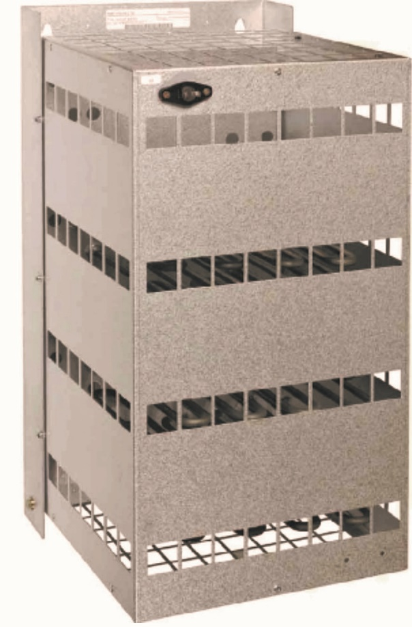
• Country of Origin: Iran (IR) – made by CDP.co
• Invoice Description: Braking resistor SAFUR90F575 CDP
• Made To Order: Yes
• Minimum Order Quantity: 1 piece
• Selling Unit of Measure: piece
• Stocked At (Warehouses): CDP.co

Dimensions
• Height: 570 mm
• Length: 310 mm
• Depth: 330 mm

Technical Data
• Resistance: 8 Ohms
• Power: 24000 Watts

Test Report
• visual inspection: Yes
• Insulation Tests: Yes
• Ohm Chek: Yes

Additional Information
• Accessory Group: Braking option
• Accessory Type: Braking system
• Product Main Type: SAFUR 90 F 575 CDP
• Product Name: Braking resistor

