SAFUR 125 F 500 CDP

General Information
• Global Commercial Alias: SAFUR 125 F 500
• Product ID:
• Type Designation: SAFUR 125 F 500 CDP
• Catalog Description: Braking resistor SAFUR125F500 CDP
Ordering
• Country of Origin: Iran (IR) – made by CDP.co
• Invoice Description: Braking resistor SAFUR125F500 CDP
• Made To Order: Yes
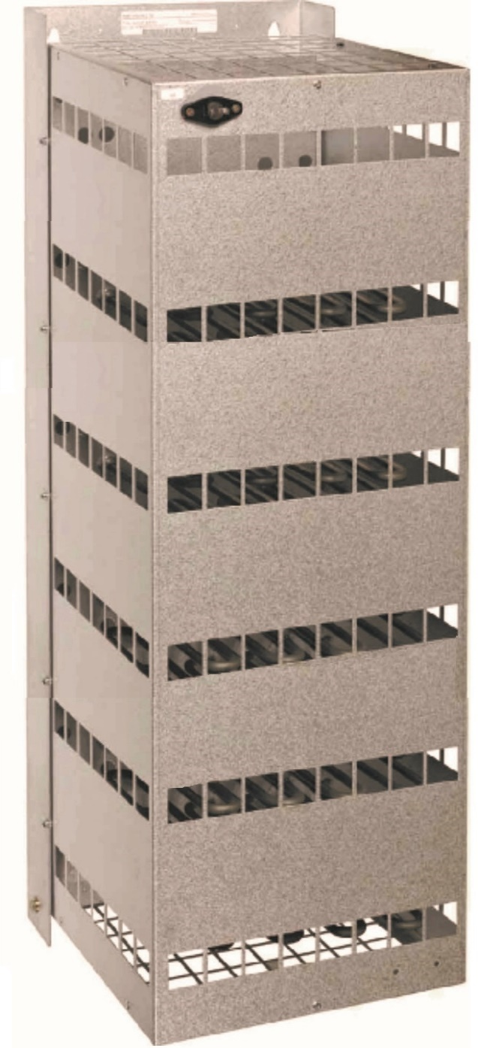
• Minimum Order Quantity: 1 piece
• Selling Unit of Measure: piece
• Stocked At (Warehouses): CDP.co

Dimensions
• Height: 940 mm
• Length: 310 mm
• Depth: 330 mm

Technical Data
• Resistance: 4 Ohms
• Power: 48000 Watts

Test Report
• visual inspection: Yes
• Insulation Tests: Yes
• Ohm Chek: Yes

Additional Information
• Accessory Group: Braking option
• Accessory Type: Braking system
• Product Main Type: SAFUR 125 F 500 CDP
• Product Name: Braking resistor

